Q1 : Write a program that creates a GUI similar to a Microwave Oven interface as shown below.

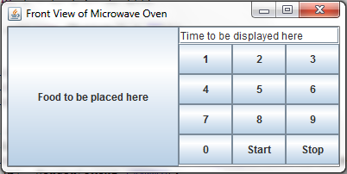

Q2: Write a program that creates a Frame having OK and Cancel buttons. Program should print on the console which button the user clicked.

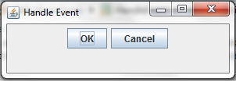

Q3: Write a GUI application as shown in the Figure. Each time the "Count" button is clicked, the counter value shall increase by 1.

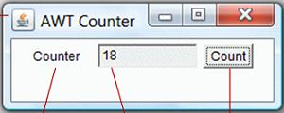

Q4: Design a GUI similar to calculator of windows operating system as shown below.

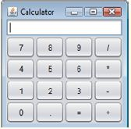

Q4: Design a GUI, as shown in diagram, to display n and factorial of n, as shown. Clicking the "Next" button shall increase n by 1. n shall begin at 1.

